Online Auction

User Manual

**Slippery Rock University of Pennsylvania**

Contributions by:

**Fall 2023**

Timothy Holtz – tth1003@sru.edu

Douglas Maxwell – dsm1015@sru.edu

Luke McElligott – lpm1006@sru.edu

Contents

Getting Started 3

Index Page 4

Sign-Up Page 4

Email Verification 6

Login Page 7

The Home Page 7

Searching 8

Social 9

User Account 11

Selling Manual 15

Browse 18

Buyer Manual 18

Bidding Manual 26

Watchlist Manual 28

Ticket System – User Perspective 29

Employee Page 30

Ticketing System - Admin Perspective 30

Add Account – Admin Perspective 33

View Users – Admin Perspective 34

View User Items – Admin Perspective 35

View Logs – Admin Perspective 36

Conclusion 37

Notes and References 37

# Getting Started

This is a web-based application developed through and by students at Slippery Rock University. The purpose of the project is to develop software capable of achieving a variety of tasks with regards to buying and selling products. This application is still in the development phase; therefore, this manual was created with the intent of informing the individuals working on the project with the foundations of the project.

To get started working on the application, reference the ‘Install Manual,’ which can be located within the Documents folder within the assigned project file.

After successful installation, development of software can begin. This application provides the developers with two user accounts that are intended to be used for testing the software. The credentials to these accounts are as follows:

**Regular User Accounts:**

Username: userName

Password: testPass

Security Code for Visa Ending in 7892: 987

Security Code for Discover Ending in 1234: 123

Username: sellerName

Password: testPass  
  
Username: sellerName1

Password: testPass

**Administrative User Account:**

Username: newadminwidget

Password: thisismypass

**IT User Account:**

Username: ITstaff

Password: ITpass

**Super Admin Account:**

Username: newadminsuper

Password: thisismypass

Utilize these accounts to gain access to the web page via regular or administrative users. The following pages will provide insight into how to effectively use the application.

# Index Page

This is the landing page for the website reference Figure 1. Its intention is to prompt the user to select one of the categories presented before them. From this page, the following actions can be performed.

1. **Sign Up** – redirects the user to the sign-up page containing the form to create new user.
2. **Log In** - prompts the user to sign in, and redirects to user or admin portal (varies depending on account privilege).
3. **Browse** - redirects the user to another page (allows an individual to browse listings without an account).
4. **Mission Statement** – redirects and displays mission statement and expectations.
5. **FAQ** - redirects and displays Facts and Questions.
6. **Contact US** - redirects to form that can be submitted for review.

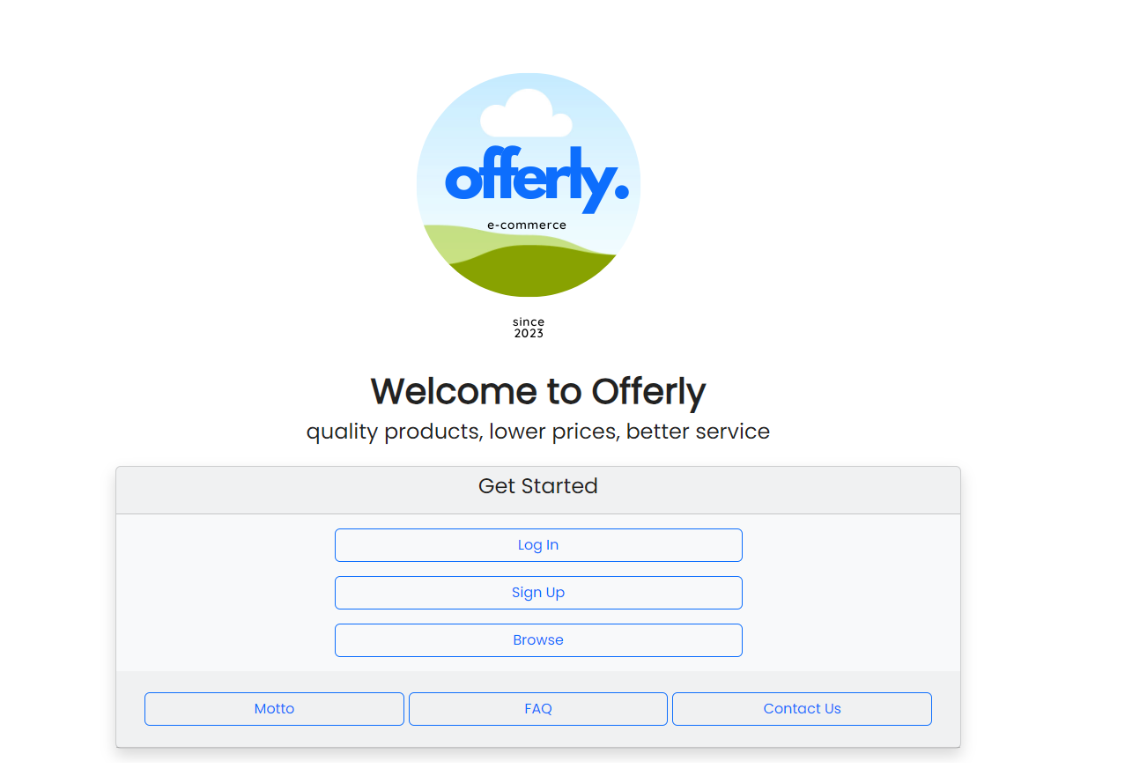

Figure 1

# Sign-Up Page

This is the sign-up page for the website reference Figure 2. Its intention is to allow the creation of a new user. From this page, the following actions can be performed.

1. **Personal** – under this category the user is required to input the following data:
   1. First Name.
   2. Last Name.
   3. Email.
   4. Phone Number.
2. **Account** – under this category the user is required to input the following information:
   1. Username.
   2. Password.
   3. Confirm-Password
   4. Optional Input:
      1. Bio.
      2. Profile Image.
3. **Security Questions** – provides three security questions to the user must answer for account creation.
   1. Each question can be clicked to reveal other questions to choose from.
4. **CAPTCHA** - This is a verification image called a CAPTCHA. The CAPTCHA will display a random series of letters/numbers and the user will need to copy them into the “CAPTCHA ANSWER” correctly.

Figure 2

# Email Verification

After successful account creation, the user will be informed that the account is created and will need to verify the account via email for the application. Reference Figure 3.

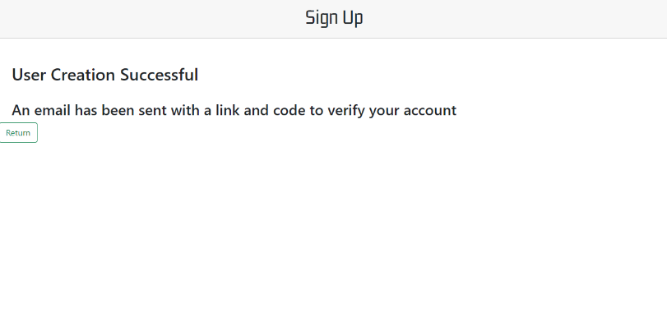

Figure 3

As mentioned above, an email containing a verification link will be sent to the user. The link will redirect them to verify email by inputting username and verification code. Reference Figure 3.1.

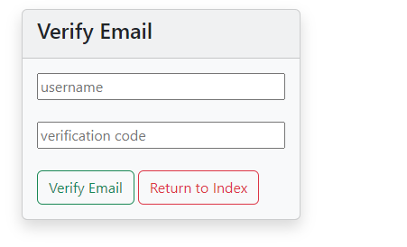

Figure 3.1

On Successful verification the user will be notified by onscreen text saying “Verification Successful” as well as a prompt to return to the login page. Reference Figure 3.2.

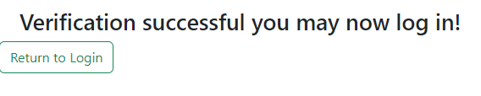

Figure 3.2

# Login Page

This is the login page for the website reference Figure 4. Its intention is to allow a user to sign-in to their account. From this page, the following actions can be performed.

1. **Username Text CTRL** – requires username input from user.
2. **Password Text CTRL** – requires password input from user.
3. **Forgot Username or Password** – This will redirect user to steps needed to reacquire account information.
4. **Don’t have an Account, Sign-up** – redirects user to sign-up page.
5. **Sign** **In -** redirects user to home page if credentials are valid else prompts user to re-enter correct information.
6. **Back –** will take the user back to the landing page.

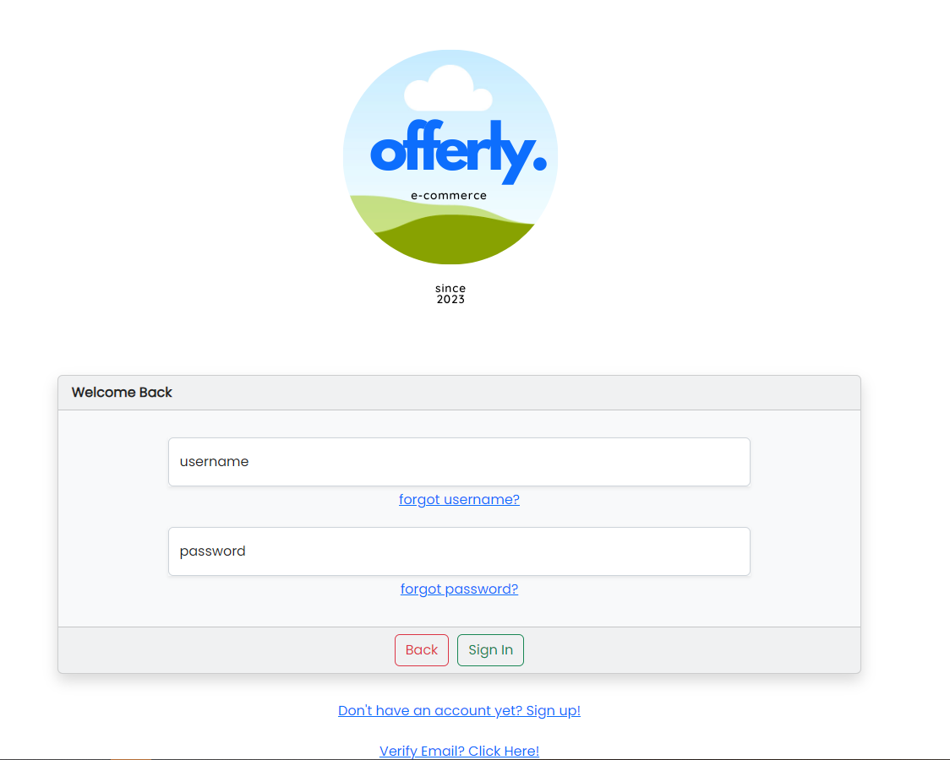

Figure 4

# The Home Page

Once you log in you will be brought to the home page – if your role is an administrator, you will be brought to the employee page. The home page has several buttons at the top which can lead you to different pages on the site. The ‘User Account’ button will redirect the user to view/edit his/her/they account. On the left side of the screen are the tabs ‘Home,’ ‘Browse All Items,’ ‘Sell an Item,’ ‘Social,’ ‘My Messages,’ and ‘Need Help.’ The Home screen will display Purchased Items, Sold Items, and Your Listings. ‘Browse All Items’ will redirect the user to view all current listings. ‘Sell An Item,’ will take the user through the processes of listing an item. ‘Social,’ will display the user’s friends and allow them to view the accounts or add new friends. ‘My Messages’ is the message center for the user, allows them to view inbox, sent items, spam, trash mail, and compose messages to other users. ‘Need Help?,’ allows the user to create technical tickets and view them. All these tabs will be explained in greater detail later in the manual.

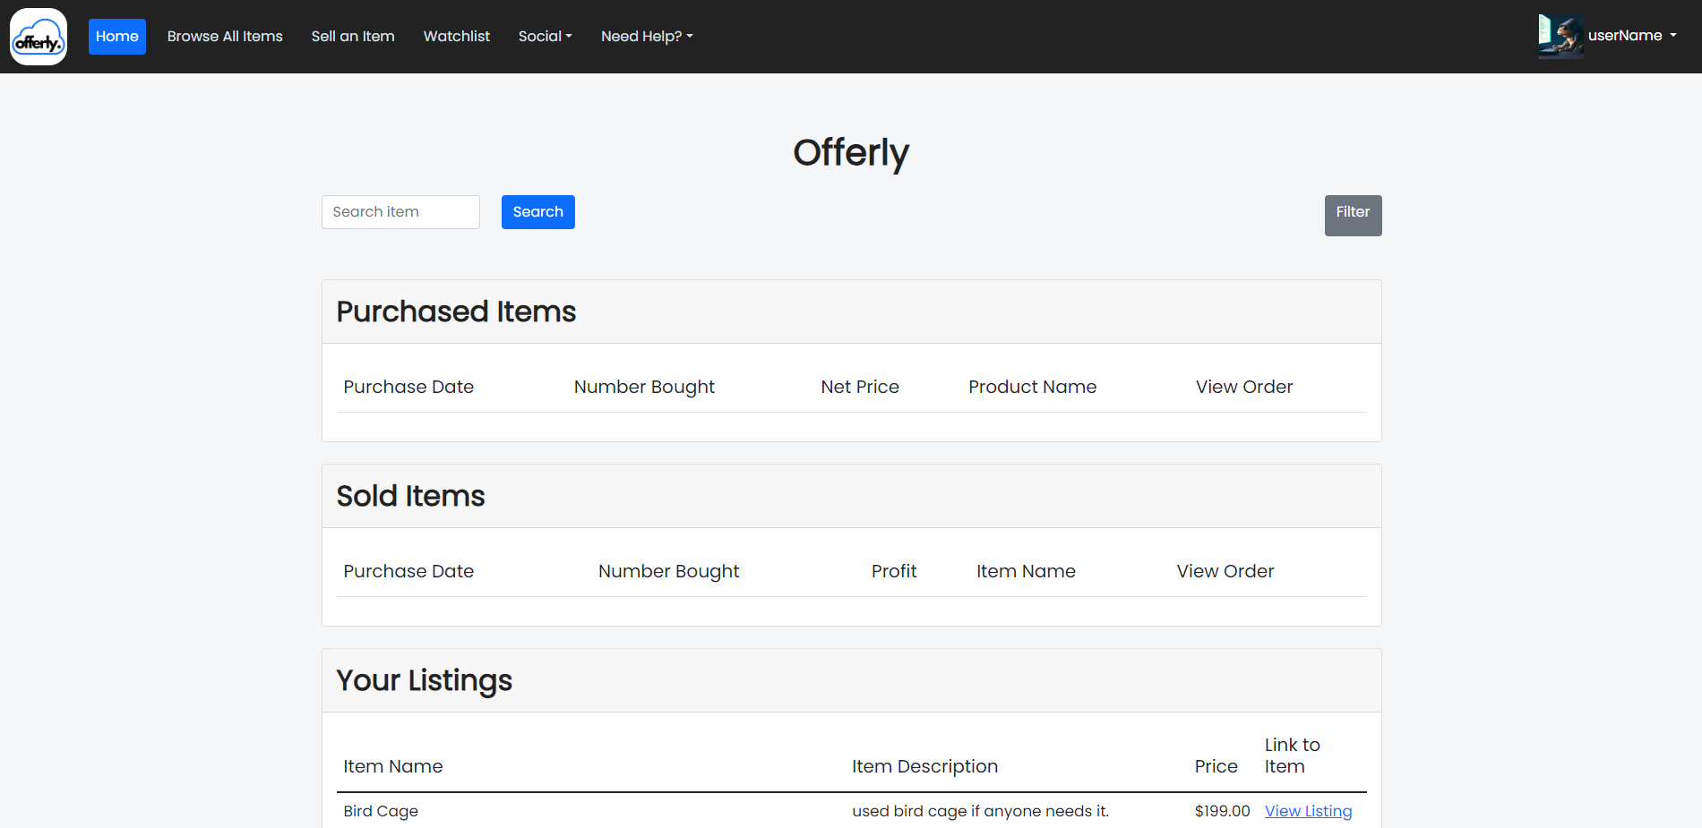

Figure 5

# Searching

Searching can be done in two ways, the first is simply by selecting the search button located at the top of the home page. This will direct you to the search page where filtering can be done. See Figure 6.

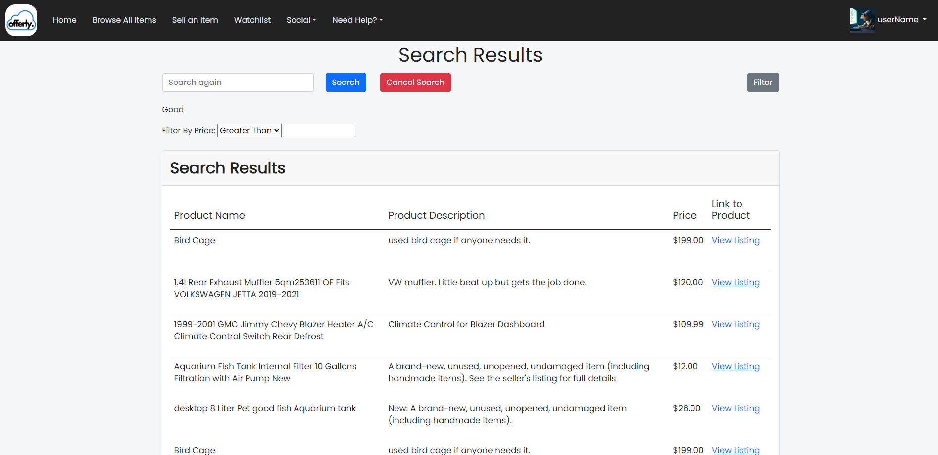

Figure 6

The second method involves filtering items directly from the home page. This can be done by selecting the filter button at the top of the home page, which will activate a drop-down menu for filtering techniques to choose from. See Figure 7.



Figure 7

# Social

The Social tab allows a user to add other users as a friend. From there they can view their profile, message them, or remove them as a friend. can add other users on the site as a friend by sending them a request. Users can also use the Gear Icon next to “Add Friend” to toggle how they want to send their request (search via username or email).

Figure 8.1

Figure 8.2

Figure 8.3

# User Account

The user account button activates a drop-down box that leads to three separate pages regarding user account information. See Figure 9.

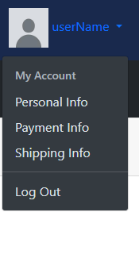

Figure 9

Personal Information Page:

This page displays the personal attributes of the account such as name, username, userid, email address, etc. See Figure 9.1. It also allows the user to edit their personal info or return home. Additionally, the user can enable Two Factor Authentication. This allows an extra level of security before logging into a user’s account. If 2FA is enable, the user will have to enter a code that is emailed to them after signing in with their credentials.

Figure 9.1

Payment Information Page:

This directs the user to a page where they can enter payment options. The tabs on the top allow for credit cards, PayPal, and Direct Deposit. If the user already has card info input, it will be displayed above as the type of card as well as the last 4 digits of the card number. The user will also be prompted to relog in when deleting, editing, or adding new card details. See Figure 9.2, 9.3, 9.4, and 9.5.

Figure 9.2

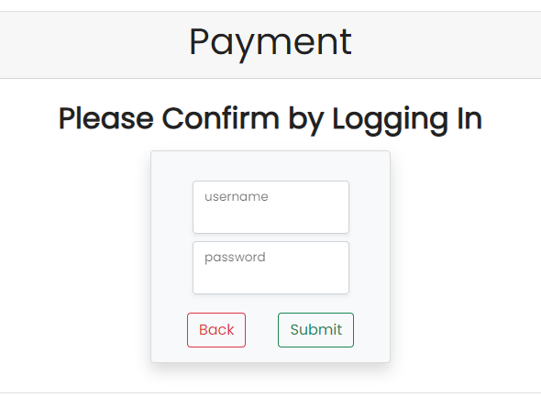

Figure 9.3

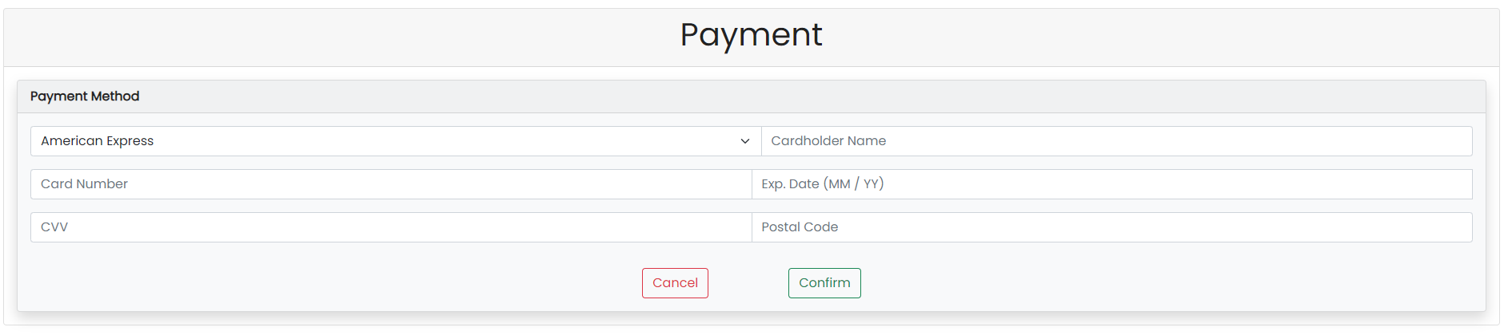

Figure 9.4

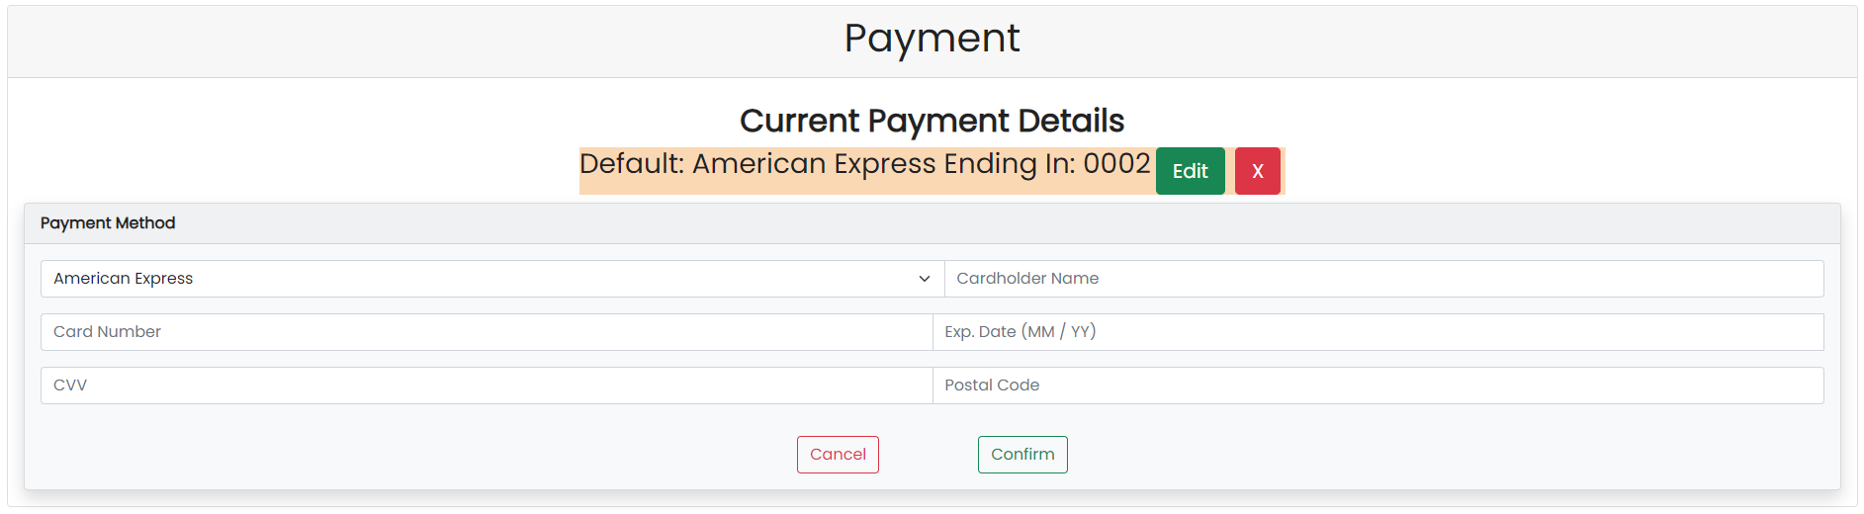

Figure 9.5

Shipping Information Page:

This directs the user to a page where they can enter shipping options. If the user already has shipping info input, it will be displayed above as the address. The user will also be prompted to relog in when deleting, editing, or adding new card details. See Figure 9.5, 9.6, 9.7, and 9.8.

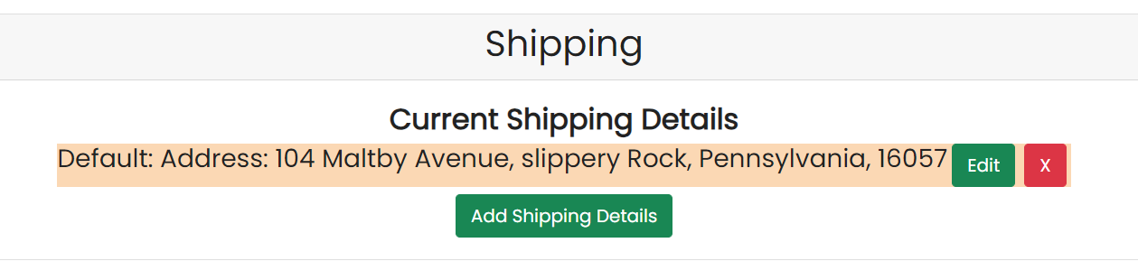

Figure 9.6



Figure 9.7

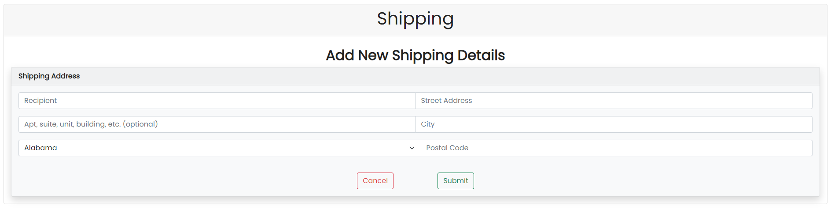

Figure 9.8

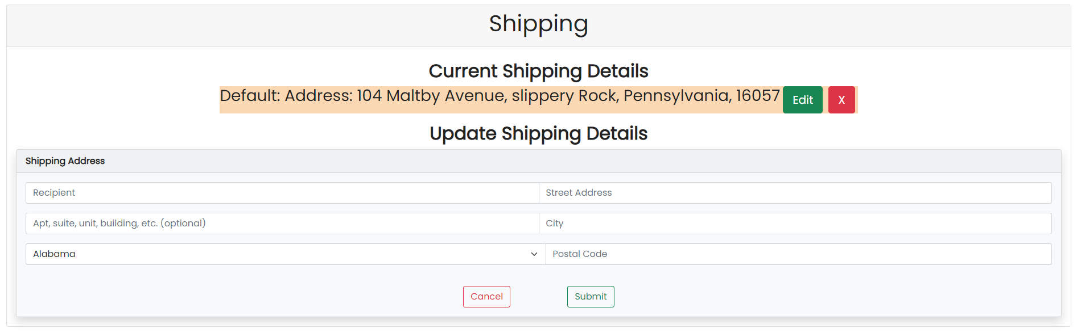

Figure 9.9

# Selling Manual

To create a new listing, the user must click the ‘Sell an Item’ tab located on the home page. Once redirected, the user is prompted to select a category for the listing, see Figure 10.

Figure 10

After selecting a category, an Item Specifications option will appear. From here, the user can input specifications for the recommended attributes, or they can add their own specifications with the “+”. Click the “-“ to remove an attribute. See Figure 10.1.

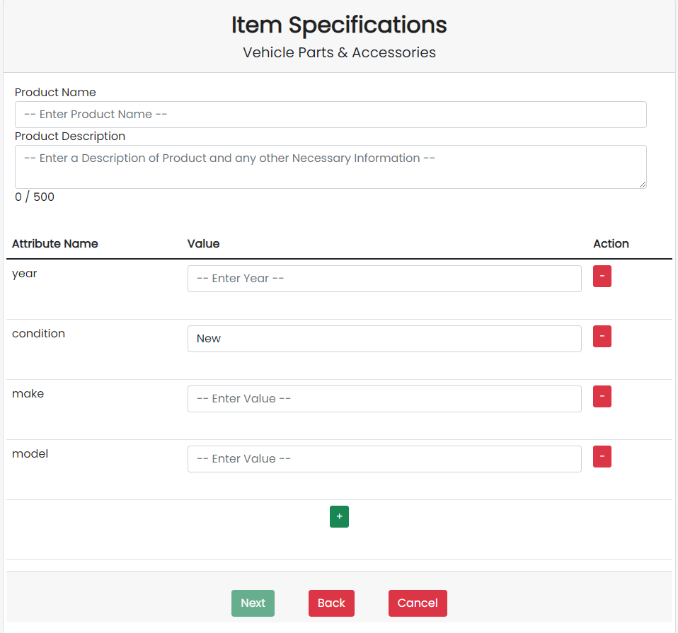

Figure 10.1

After providing the listing information, the user will be directed to another menu prompting for price, starting auction price, quantity, a cover photo of the item to be displayed on the browse page, and other photos of the item. See Figure 10.2.

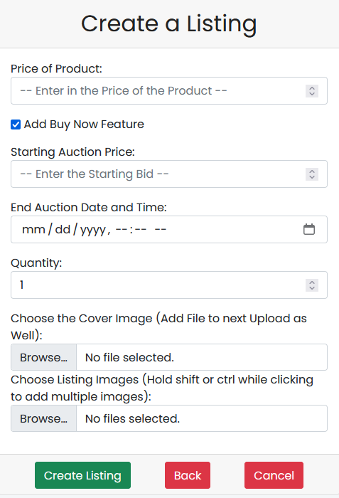

Figure 10.2

After adding this information, the listing will be created. The user is redirected to the home page where the listed item can be seen.

Once an Item is sold to a buyer, it is the seller's responsibility to upload ship the item. It is recommended that the seller uploads the shipping label to the transaction page. Sold items are shown on the homepage as seen in Figure 10.3. Reference Figure 10.4 to see how to upload a shipping label after clicking the “Open Sold Item” link.

Figure 10.3

Figure 10.4

# Browse

The browse section displays listings both for the view of registered and unregistered users. Provides some details regarding the product and allows the individual to view listing if registered, else redirects to login page to get further attributes. Reference Figure 10B.

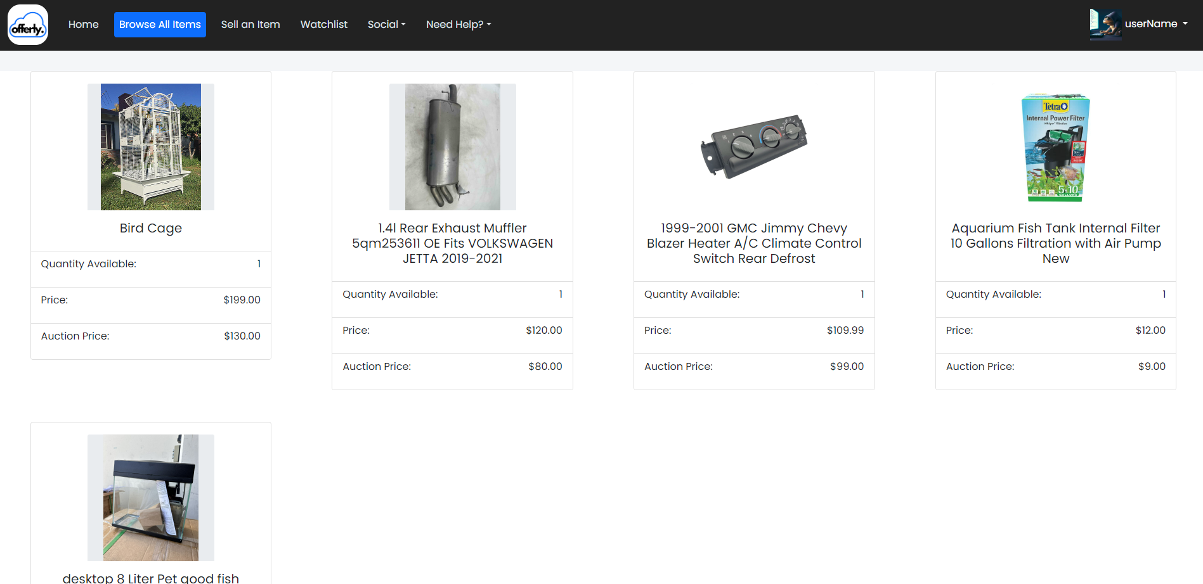

Figure 10B

# Buyer Manual

After browsing widgets and finding one of interest the user should click the “View” button to view all the listings information, as well as, to see any other pictures that the seller has listed. Reference Figure 11

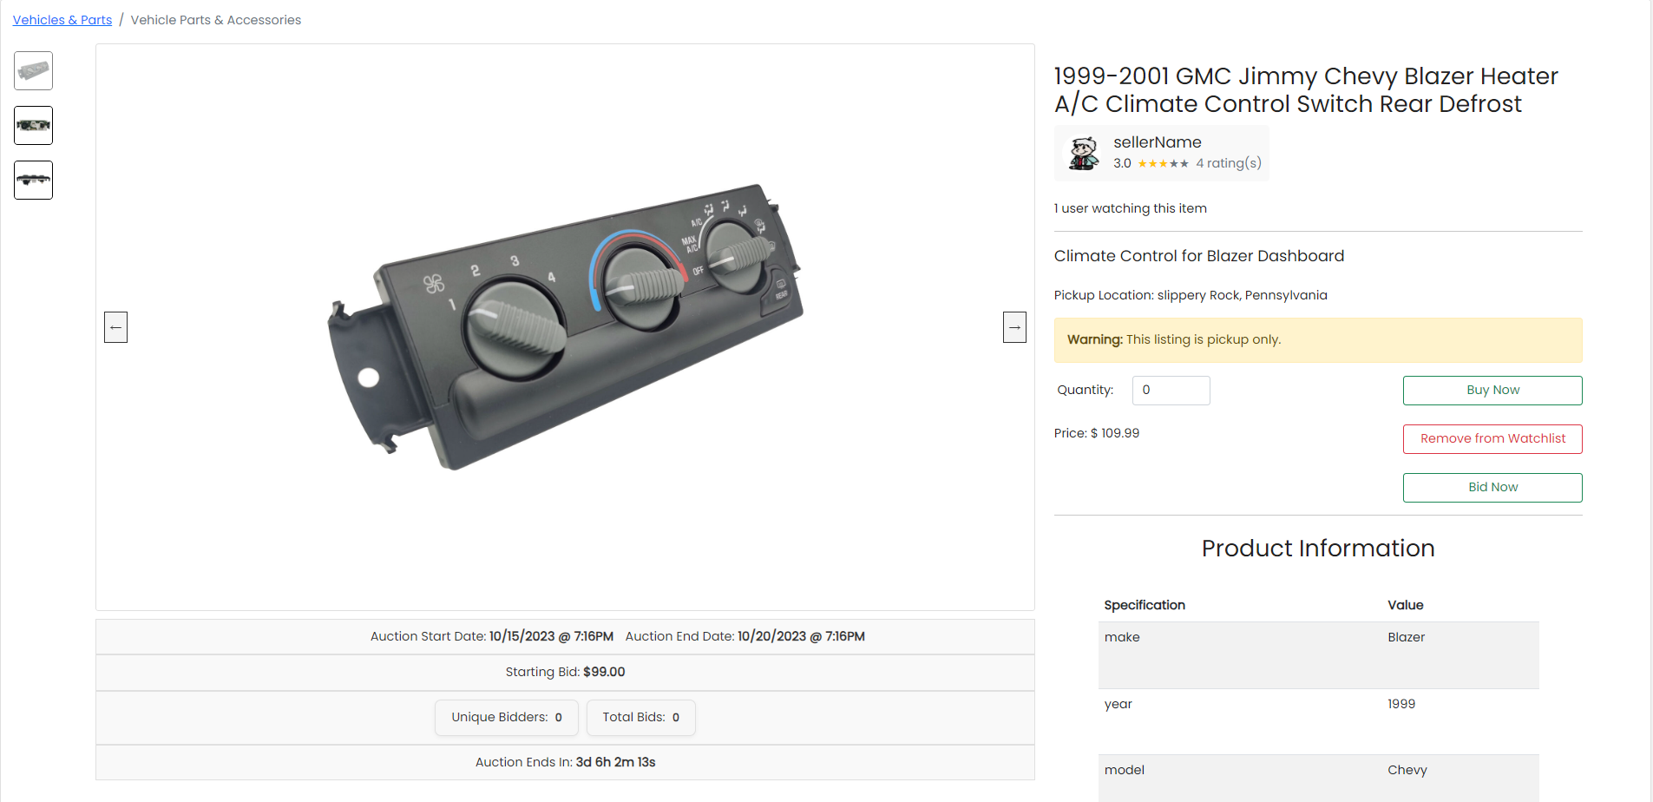

Figure 11

Additionally, the user can bid on a listing that they want by clicking on the Bid Now button and entering a bid price that’s higher than the current bid. Reference Figure 11.1 and 11.2.

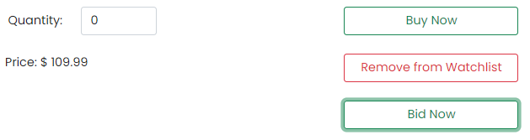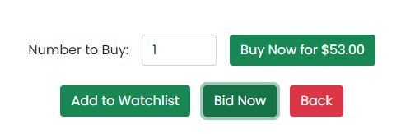

Figure 11.1

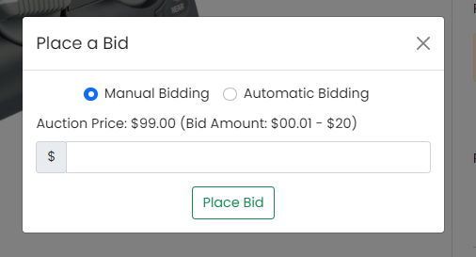

Figure 11.2

After viewing all the information and deciding that this meets the user’s criteria and that they wish to purchase the item they should then input the number they wish to buy and click purchase. Reference Figure 11(if the user has no default) and Figure 11.3(The user has both a default shipping address and payment details).

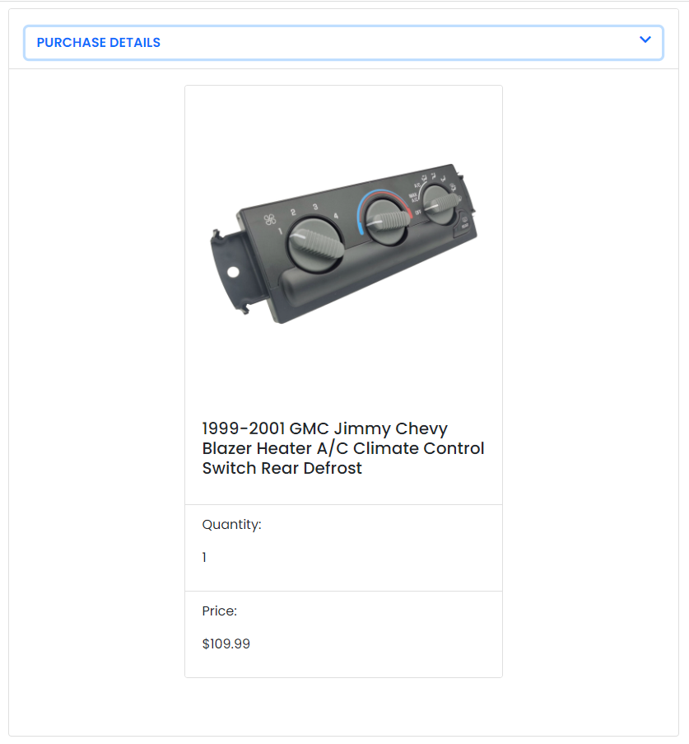

Figure 11.3

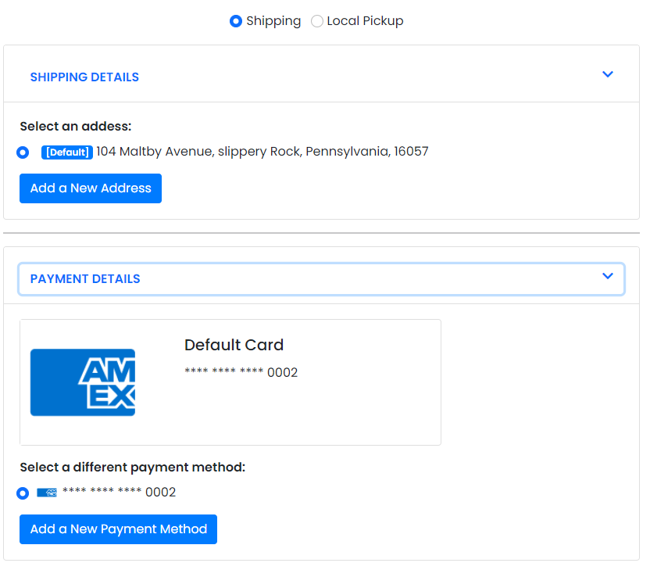

Figure 11.3

From this page the user can use an existing CC by inputting that card’s security code and clicking confirm. The user can also add a new card by clicking “Add New Credit Card” (Figure 11.4). The user can also click to change their existing shipping address by clicking change under Shipping Address (this will say you must add a shipping address if there was no default) (Figure 11.5). The Shipping section has a similar layout to the payment details one. (Figure 11.6).

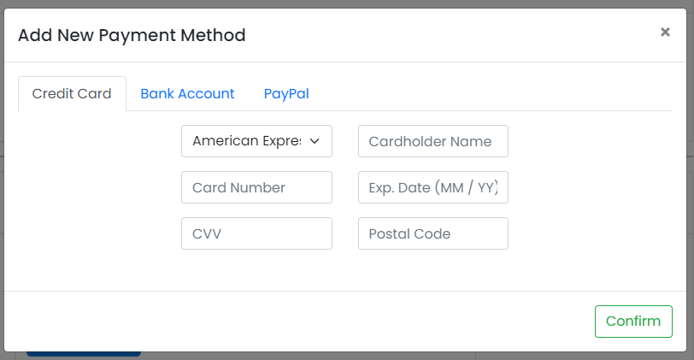

Figure 11.4



Figure 11.5

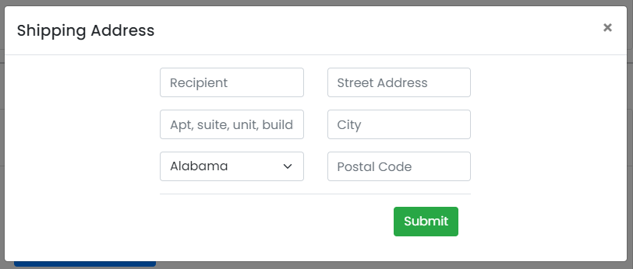

Figure 11.6

Once all of the necessary information has been added or confirmed (both card details and shipping address), the user will then be prompted to confirm the information before clicking purchase which will purchase the item. Reference Figure 11.7

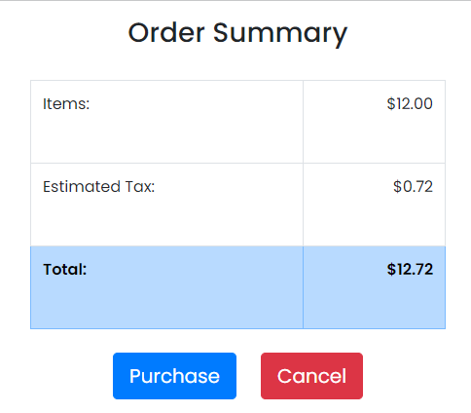

Figure 11.7

Upon purchasing the item, the user will be directed to the Home page and can see the Purchased Items table populated from what they bought. Reference Figure 11.8

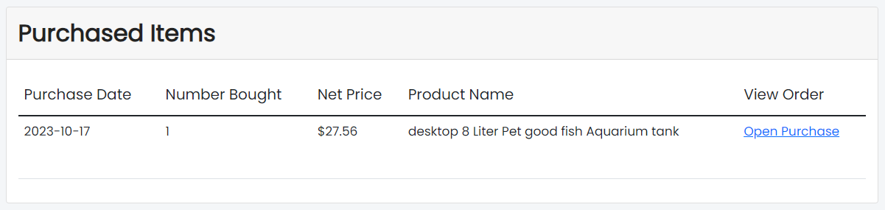

Figure 11.8

A buyer can view information about their purchase by clicking “open purchase”. If the user selected for the item to be shipped. They will see shipping information displayed on the page. The shipping information will only be updated when a seller has uploaded the shipping information. Reference Figure 11.9

Figure 11.9

If the buyer is not satisfied with their purchase, they are eligible for a refund if they navigate to the “Need Help?” tab in the Header. From there, the buyer can click on “Refund” to be directed to the refund page. Reference Figure 11.10

Figure 11.10

On the Refund page, the buyer can click on the Refund button and go the process of being refunded. Reference Figure 11.11, 11.12, and 11.13

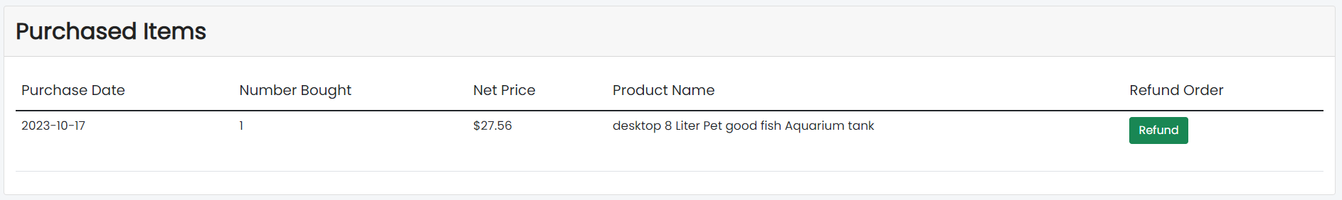

Figure 11.11

Figure 11.12

The ticket will be sent to an employee for them to look over the ticket and decide whether the refund is valid or not. The user will see that their refund ticket is pending and will be notified is an employee approves or declines the refund.

Figure 11.13

# Bidding Manual

Buyers have the option to bid on items if the seller enabled bidding. In this case, the seller will select the starting bid price for the item. From here, the bidder has the option to manually or automatically bid on products.

Manual bidding means that the user will place a one-time bid on the product. They will have to pay attention to the auction end-date and price in order to make sure that they are not out-bid.

In order to manually bid, the user will have to click “Bid Now” on the market listing page. This opens up the bid modal and manual bidding is selected by default. The user can then place a bid (ranging from $0.01 to $20.00) that will be added to the product’s auction price.

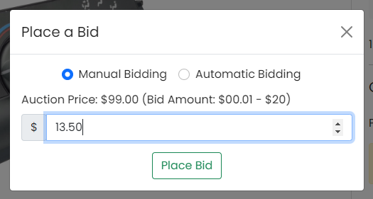

Automatic bidding differs from manual bidding as automatic bidding allows the system to place bids for the user. For this type of bidding, the user inputs the maximum price they are willing to spend on the product, and the system places bids in increments for that user until their maximum price is reached.

To set up automatic bidding, the user can press “Bid Now” on a product listing. Instead of the default, manual bidding, they can click “Automatic Bidding”. This will show a different input form. From here, the user can input the maximum price they are willing to pay for the product.

After setting up automatic bidding, the system will check to see whether there is another user with automatic bidding. If there is, it will raise the current auction price of the product to the lower of the two automatic bid maximum prices.

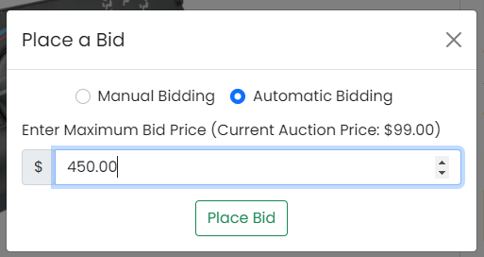

# Watchlist Manual

Buyers have the option to add a market listing to their watchlist so they can revisit the item later.

Adding an item to your watchlist:

The “Add to Watchlist” button can be found when viewing an item as displayed in figure 11.2. This button then alerts the user that the item has been added to their watchlist.

Viewing your watchlist:

A user can view their watchlist by clicking on the “Watchlist” button seen in figure 11.

Removing an item from your watchlist:

Items can be removed from your watchlist by clicking the “Remove from Watchlist” button on the “Watchlist” page, as illustrated in the figure below.

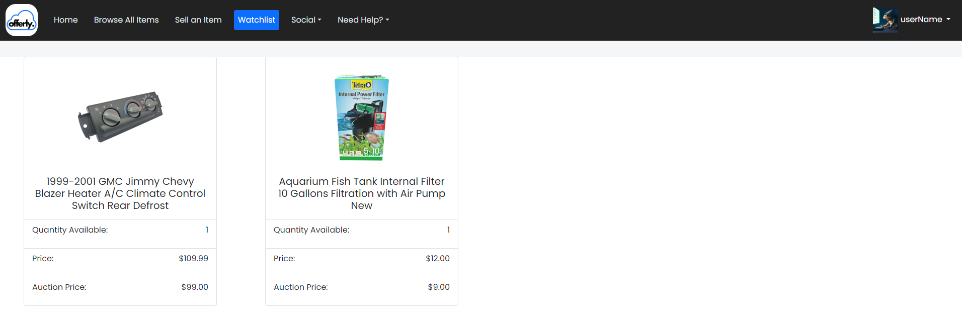

# Ticket System – User Perspective

The ticket system via user is in the navigation tab on the home page under ‘Need Help?’. See Figure 12.

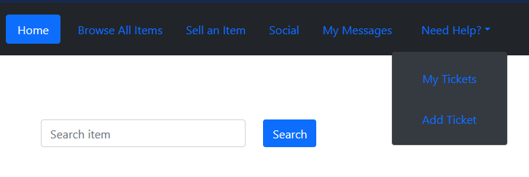

Figure 12

The user can select ‘My Tickets’ or ‘Add Tickets.’ Depending upon the selection, the user will be redirected to different pages. The ‘My Tickets’ tab allows the user to see the pending tickets they have put in for review. See Figure 12.1.

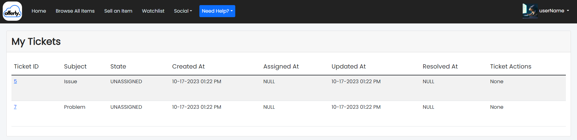

Figure 12.1

The ‘Add Tickets’ tab prompt the user to input issue information. See Figure 12.2.

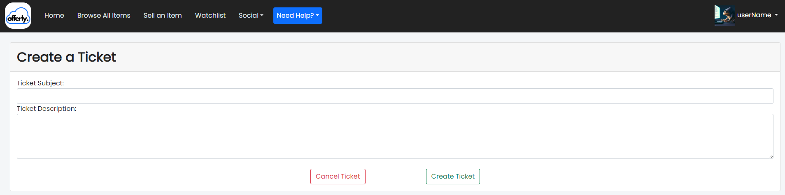

Figure 12.2

The created ticket as previously stated will appear in the ‘My Tickets’ tab. See Figure 12.3. 

Figure 12.3

# Employee Page

The employee page is the hub for the employees of this website. The admin role is the master controller and can see and perform tasks. This page contains seven navigation options, them being ‘Employee Home,’ ‘View Users,’ ‘View User Tickets,’ ‘View User Items,’ ‘Item Details,’ ‘Add Account,’ ‘My Messages.’ See Figure 13.

Figure 13

# Ticketing System - Admin Perspective

As seen in Figure 13, the administrator home page contains a variety of functions that can be accessed via navigation bar. The ‘View User Tickets’ tab can be utilized to handle ticket requests from the user. See Figure 14.

Figure 14

A variety of functions can be performed from this screen. By clicking the ‘Ticket ID’ this will open the ticket details. This can be seen in Figure 14.1. By clicking on the ‘Reporter’ of the ticket, user details will be displayed to the administrator. See Figure 14.2. The ticket can also be assigned to an administrator by utilizing the drop-down box under ‘Update Assignee’ and clicking the submit button. This can be seen in Figure 14.

Figure 14.1

Figure 14.2

# Add Account – Admin Perspective

This tab can be located on the navigation bar of the admin home page. This allows administrators to add new users. (Users and users w/ higher privileges). This is represented in Figure 15.

Figure 15

# View Users – Admin Perspective

This tab is located on the navigation bar of the admin home page. This allows administrators to search for users of the application. Has implemented search bar w/ filter options. See Figure 16.

Figure 16

As seen in the image, a variety of the categories have been hyperlinked. By clicking on the hyperlink under that category, filtering pertain to the category will occur according to the user initiated in first column of each row.

# View User Items – Admin Perspective

This tab is located on the navigation bar of the admin home page. This allows administrators to search for items and sellers of the application. Has implemented search bar with filter options. See Figure 17.

Figure 17

# View Logs – Admin Perspective

This tab is located on the navigation bar of the admin home page. This allows administrators view logs of all actions by users. As the admin, you can filter logs based on category as well as a specific time frame. See Figure 18.

Figure 18

# View Revenue – Super Admin Perspective

Super admin accounts are the only account role that have permission to view generated revenue. When logged in as a super admin, a “Revenue” tab becomes visible in the navigation bar. When clicked, it brings the super admin to a page where the total revenue generated from user transactions can be seen. By default, all transactions that happen within the system automatically takes 10% of the transaction amount and places it into this revenue fund. From here, super admins would be able to transfer this amount into a company bank account.

# Conclusion

This is a user manual in accordance with the most recent version of the application software. Included below is a notes and reference category that contains the information from previous group manuals. It is there as a reference for later use in case of any unknowns arising while implementing new code and documentation to the project.

# Notes and References

**Index Page Notes:**

A: Prompt user to login – redirects to Home Page

B: Browse Button – currently does nothing

C: Sign Up – redirects to the user sign up form

D: Verify Email – Use this link to unlock a new account with the verification code sent to your email upon signing up

E: Mission Statement: - Displays the “company’s” mission statement

F: FAQ- Displays a page with common questions and answers

G: Work with us – This directs to a page where anyone can submit an online application

**Sign Up Page Notes:**

A: A standard sign-up form. A username must contain at least 6 characters and be unique. Password must contain at least 8 characters 1 of which needs to be a special character such as (! @#$%)

B: This is a verification image called a CAPTCHA. The CAPTCHA will display a random series of letters/numbers and the user will need to copy them into the “CAPTCHA ANSWER” correctly.

C: These (will) contain links to various informative pages, click on them to check them out.

Sign Up Page: The user must fill out the form completely to begin the user creation process. Upon completing this form and clicking the “add user” button the new user will be brought to the secret questions page which sets questions for the user to answer that can later be used in recovering a lost or forgotten password.

Select each secret question from the drop-down menus by clicking on the question prompts. Once you have answered all 3 questions the user creation process is over, and you will have received an email with the verification code to allow the account to get started.

**Email Verification Notes:**

After a first sign up, the user is returned to the index page. On this page one simply needs to click the “Email Verification” button or “D” from figure 1.a. The user is prompted to type in their username and the verification code that was sent to their email address upon sign up. If the username and the verification code match then now the user is fully enabled to login.

**Login Page Notes:**

A: Redirects to form that will help a user recovery their username

B: Redirects to a form that will help a user recovery their password

C: Returns to the index page without doing a log on attempt

Login Page: The user must enter their username in the top field and password into the password field and then press the Sign In button to log on. If either are incorrect error messages will appear on screen. If one is having difficulty remembering their username or password use the links to start recovery.

**Home Page Notes:**

Once you log in you will be brought to the home page – if your role is an employee, you will be brough to the employee page. The home page has several buttons at the top which can lead you to different pages on the site. The User Account page allows you to view your account information, simply click on this button to view this page. The buttons below this are Create Widget, Logout, and Messages. Create Widget will allow you to make a posting on the site for you and other users to view. This will be covered in more detail in a later section. Logout will log you out of your current session and return you to the login index screen. Messages will take you to the messaging page to see messages from other users. This page will be covered in a later section.

**Searching Notes:**

Below all of this is the search section of the home page. Here you can first select a category through the drop-down menu or leave it on all to search all items. If you just hit search or the enter key right after selecting a category, you will see all the listings from that category. Next, put in a term for the search bar such as ‘computer’ or ‘truck’ just like in Figure 3 and if any listings have that in their names or descriptions as well as the category you selected, then they will appear in the search results page when you hit search or hit the enter key. You can also filter by price by selecting greater than or less than a certain price. Simply use the drop-down menu that says greater than to choose ‘Greater Than’ or ‘Less Than’ and enter a dollar amount as shown in Figure 4. You can enter in USD by increments of 0.01. If you hit search or press the enter key after doing so it will display all listings with a price greater or less than the amount entered. Then when you hit search, it will consider all the parameters you set in the various options and show any listings that apply on the search result page as shown in Figure 5. This used the Electronics category, computer in the search bar, and greater than 50.02 as the price.

**User Account Notes:**

The User Account page allows you to view the information for your account such as your Username, Display Name, Bio, and the date you joined. You can edit this information by clicking into the textboxes on the page and entering the new information. Then click the ‘Update Information’ button and it will take what you changed and update your profile with that information. There are some other buttons on this page that allow you to update payment and direct deposit details. Simply click on these buttons and enter the new information then click save.

**Create Widgets Notes:**

To create a listing, first click the ‘Create Widget’ button on the home page. This will bring you to a page to select a category for your listing as shown in Figure 4. For now, we are limited on the types of listings we can support so choose whatever is closest to the item you want to list then click next. Next you will be prompted to select a Subcategory, once again select the one closest to what you are selling and click next as shown in Figure 5. You will then see a page with several text boxes, drop down menus, and buttons. Enter the information to the best of your ability such as the model of the item or the brand as shown in Figure 6. Then click next or hit enter. Finally, you will be asked to enter a price and quantity, simply enter this information and click the last button. This will create your listing and allow it to be searched.

**Payment Notes:**

Payment information is used to add the credit card that you will use to purchase items from the marketplace. Navigate to the “User Account” page as described in the User Account section. Press the “Update Payment Details” button as shown in the below figure. This will open the “Update Payment Details Page,” shown in the below figure. The red “Cancel” button is used to return to the User Account page without making changes, while the blue “Update” button attempts to update your payment information. To successfully update your information, all the fields in the form must be fully filled out, with valid information for a credit card.

**Buyer Manual Notes:**

Begin by following the instructions for the “Searching” section to get a list of listings that you can purchase from. Select a listing you would like to purchase from by selecting the “View Listing” link, as shown in the below figure. Opening the listing will present you with the webpage in the following figure. To attempt to purchase an item, you must fill out the “Number to Buy” form at the bottom, and then press the “Purchase Items” button. The number of items bought must be greater than 0, and it cannot exceed the number of items available for purchase. This will open the page for confirming your shipping address, as shown in the below figure. To continue your purchase, you must fill out the form with the shipping address, like is shown in the below picture, and then press the blue “Purchase” button. The purchase can also be cancelled using the red “Cancel” button. Once the shipping address is confirmed, the page for finalizing the purchase will be opened, and is shown with the below figure. From here, you can purchase either via credit card, which uses your existing payment information, or by submitting a PayPal purchase. You can select which purchase method to use by expanding either of the dropdown items highlighted in red. In either case, a form must be filled out with valid payment information, and then submitted in the same fashion as was done for the “Confirm Shipping Address” page. Cancelling the purchase can be done by using the navigational bar alongside the top of the screen, or by pressing the red “Cancel” button that is shown when either of the dropdown menus are expanded. Follow the instructions in the “The Home Page” section to reach the home page. The list of purchases you have made will be shown as in the below picture. To view information about a purchase, click the “Open Purchase” link, such as the one highlighted in red, that is associated with the purchase you would like to view. This will open a page, like the one shown in the below figure, that shows all of the details of the purchase and its shipping information. Follow the steps described in the “Viewing Purchases” section to open the details of a purchase. The shipping address and shipping status are shown in the below figure, surrounded by the red circle.

**Selling Manual Notes:**

Follow the instructions under the “Create Widget” section. A Market Listing is created through this process.

As a seller, you can modify Market Listings that you have posted. Begin by following the instructions under the “Searching” section to find one of your widgets. From a successful search, select one of your Market Listings by pressing the “View Listing” button as highlighted below. This will open a market listing view, as shown below. This page is like the page that is seen from the “Purchasing Items” section, but with the available actions changed. Within the top bubble shown on the diagram, there is a button to return to the homepage, and another button that removes the Market Listing. Within the bottom circle on the diagram is a form that you can use to change the price or number of items available for this listing. As a seller, you can view the list of transactions from buyers. To do this, begin by following the steps under the “The Home Page” section. This will show the page like the one in the following figure. Alongside the bottom of the page, there is a listing of transactions where you are the seller. This section can be seen in the following diagram, within the red oval.

Follow the process to view your sold items. On the detailed page, there is a form at the bottom of the page that you can use to update the shipping information, which involves adding information on the carrier, as well as the shipping date and arrival date. Change these values and then press the submit button to add or update this information. The user will have already provided their shipping address to you while purchasing, which you can use while providing information to the carrier.

**Employee Page Notes:**

A: This column will contain operational buttons that are dependent on the employee role.

B: This column displays the results of searches such as searching a user and then displaying all the non-encrypted information in a table.

C: This last column will allow certain roles to make changes to the searched objects.

The employee page is the hub for the employees of this website. The admin role is the master controller and can see and do every task. The customer service and quality control roles have access to issues that users run into in the form of tickets. Tickets will contain a description of what occurred and the entities that were involved. The hiring agent can use the employee page to go over any of the applications that have been submitted to the website. Lastly, the sales role with have numerical data gathered from users, sellers, buys, etc. represented in various charts and tables for analysis and statistics.

**Ticket System User Notes:**

A: From the Normal user login-screen. The ticketing page will appear on the navigation bar to the left.

B: The user is now able to view the tickets he has created in the “My Tickets” option, create a new ticket in the “Create Ticket” option, or return to the homepage with the “Return” option.

C. If the “Create Ticket” option is selected, the user may now create a ticket. This will allow a subject and description to be filled out for the admin roles to view from

their separate log-in. Cancelling the ticket will take the user back to the “Create Ticket” page, while the Create Ticket button fill create a ticket in the system.

D. If the ticket is created, you will be taken to the My Tickets page that shows various details about the ticket. An ID is created for the ticket, along with the Subject that the user had previously created. The “State” of the ticket shows whether a ticket has been either “UNASSIGNED”, “UNANSWERED”, or “RESOLVED” depending on the admin’s progression of the ticket. This ticket information also includes when the ticket was created, when the ticket was assigned, the last time the ticket was updated, and when the ticket was resolved. The “Ticket Actions” may include the ability to re-open a closed ticket as seen in the “Resolved Ticket Example”, only if the ticket’s State is already resolved.

E. As you can see in Figure - My Tickets information, The ID of the ticket also functions as a hyperlink to the Ticketing Details page. This page shows the same information as before in larger and more readable scale, but most importantly features a messaging system between the user, and to the admin role that is assigned to the ticket. Typing a message into the Reply box, and hitting the submit option, allows the admin role who is assigned to the ticket to message and interact with the user of the ticket. The admin role assigned to the ticket is also able to reply to the messages, which the user can also see in this page.

**Ticket System Admin Notes:**

A. After logging into the Admin account, you can select the “Search Tickets” Option as seen in the Figure - Admin Navigation Bar This will take you to the list of tickets that have been created by any user.

B. Once “Search Tickets” has been selected from the navigation bar, all the tickets created by users is shown. This page shows a few more details, such as the user who reported the ticket, the level of the ticket, which is determined by the role of the administrator that the ticket was assigned to. Updating the Assignee will update who the ticket is being controlled by. Only the Assignee can reply to tickets, as well as resolve them. There are various roles that have been created that the admin can assign the ticket to, to the best of their ability considering the subject matter. Furthermore, the Ticket Actions includes as Resolve button, but again only if you are logged in as the account that the ticket has been assigned to. As seen in Figure - Admin My Tickets, I am able to resolve the ticket because it has been self-assigned to the test admin account. Lastly updating the assignee, sending a message to the user, or resolving the ticket will send an email to the user’s associated email address about the update that has been made to their ticket.

C. Also, as seen in the Figure - Admin My Tickets, the reporter of the ticket is also included as a hyperlink, which directs you to the “Search User” page, allowing you to search the user that has submitted the ticket, and directing you to the information available in the “Search User” page.

D. Lastly, as shown in Figure - Admin My Tickets, the ID of the ticket is again used as a hyperlink, which takes you to the Admin Ticket Details Page, shown below. This is where the details of the ticket are shown, but now the admin that is associated with the ticket may respond to the messages sent to the user.

**Create Widgets Notes:**

A. To sell a widget, select on the “Sell Items” Option, seen here in Figure - User Navigation Bar

B. After you arrive on the Create Widget Page, you must select a category as well as sub-category of item.

C. Now you are the creation of the specific widget. You may enter the information as desired or use the upload options below to help ease of creation. So, there are two separate upload files that exist. One is for Widget data itself and the other is for market listing. The widget id alone needs to pull or edited after creating widget and should be entered in the corresponding row in market listing file that is being uploaded.

**Admin Widget Info Notes:**

A. To Access the widgets information, select the “Widgets Info” from the Figure - Admin Navigation Bar, seen here.

Once Selected, you can select the type of widget you’d like to adjust, after hitting the “Next” button, it may take you to a sub-category page, where you can select the subcategory to adjust.

Figure - Widgets Category Details

B. Once a category and subcategory are selected, the admin may select and deselect the checkboxes as seen in Figure - Widgets Category Details, Once the checkboxes are selected and de-selected as desired, hitting the Update button at the bottom of the screen will update what attributes are to be made visible. (As Default the checkboxes are set to true/visible)

C. The Download button also in Figure - Widgets Category Details (greyed out currently), allows you to download the existing data into an excel sheet. This allows the admin to edit the excel sheet directly with the attributes for a new product in the subcategory, rather than creating a new excel sheet which may be prone to errors. (Heading etc.)